**Irish Blessing** 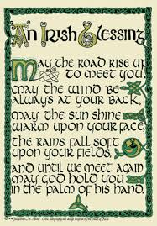

May the road rise to meet you

May the wind be always at your back

May the sun shine warm upon your face

The rains fall soft upon your fields

**Chorus:**

And until we meet again

Until we meet again

May God hold you in the palm of his hand

And until we meet again

Until we meet again

May God hold you in the palm of his hand

May the sun make your days bright

May the stars illuminate your nights

May the flowers bloom along your path

Your house stand firm against the storm

**Chorus**