**LAST THING ON MY MIND** 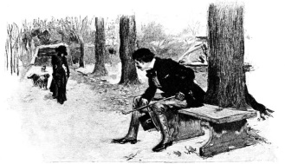

It's a lesson too late for the learnin',

Made of sand, made of sand.

In the wink of an eye my soul is turnin'

In your hand, in your hand.

Chorus:

Are you goin' away with no word of farewell?

Will there be not a trace left behind?

I could have loved you better, didn't mean to be unkind;

Oh, you know that was the last thing on my mind.

You had reasons a-plenty for goin',

This I know, this I know.

And the weeds have been steadily growin',

Please don't go, please don't go.

(Chorus)

As I lie in my bed in the mornin',

Without you, without you,

Every song in my heart dies a-bornin',

Without you, without you.

(Chorus)

Oh, you know that was the last thing on my mind.