**SCARLET RIBBONS** 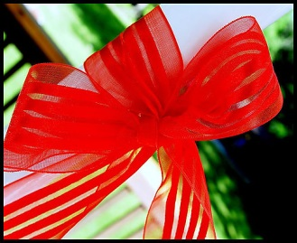

I peeked in to say goodnight

And then I heard my child in prayer

Send for me some scarlet ribbons

Scarlet ribbons for my hair.

All the stores were locked and shuttered

All the streets were dark and bare

In our town no scarlet ribbons

No scarlet ribbons for her hair.

Through the night my heart was aching

Just before the dawn was breaking.

I peeked in and on her bed

In gay profusion laying there

Scarlet ribbons, scarlet ribbons

Pretty scarlet ribbons for her hair.

If I live to be two hundred

I will always know from where

Came those lovely scarlet ribbons

Scarlet ribbons for her hair...