**Siyahamba** 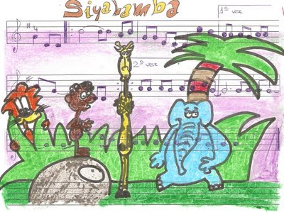

See-ah-ham-ba /ay-cuke-an-yeni /kwen-koze',

See-ah-ham-ba/ ay-cuke-an-yeni /kwen-koze',

See-ah-ham-ba/ ay-cuke-an-yeni/ kwen-koze',

See-ah-ham-ba/ ay-cuke-an-yeni/ kwen-koze',

[ay-cuke-an-yeni / kwen-koze']

Chorus:

See-ah-ham-ba...

See-ah-ham-ba/ ham-ba/ See-ah-ham-ba/ ham-ba [ooh, ooh]

See-ah-ham-ba/ ay-cuke-an-yeni/ kwen-koze',

[ay-cuke-an-yeni/ kwen-koze']

See-ah-ham-ba/ ham-ba/ See-ah-ham-ba/ ham-ba [ooh, ooh]

See-ah-ham-ba/ ay-cuke-an-yeni/ kwen-koze',

[ay-cuke-an-yeni/ kwen-koze']

We are marching in the light of love (x4)

Chorus

We are dancing in the light of love (x4)

Chorus

We are waving in the light of love (x4)

Chorus