**TIE A YELLOW RIBBON** 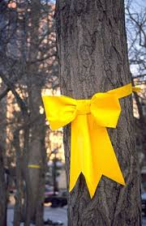

I'm comin' home, I've done my time

Now I've got to know what is and isn't mine

If you received my letter telling you I'd soon be free

Then you'll know just what to do

If you still want me

If you still want me

Whoa, tie a yellow ribbon 'round the ole oak tree

It's been three long years

Do ya still want me? (still want me)

If I don't see a ribbon 'round the ole oak tree

I'll stay on the bus - Forget about us - Put the blame on me

If I don't see a yellow ribbon 'round the ole oak tree

Bus driver, please look for me

'cause I couldn't bear to see what I might see

I'm really still in prison

And my love, she holds the key

A simple yellow ribbon's what I need to set me free

I wrote and told her please

Whoa, tie a yellow ribbon 'round the ole oak tree

It's been three long years

Do ya still want me? (still want me)

Now the whole damned bus is cheerin' and I can't believe I see

A hundred yellow ribbons 'round the ole oak tree

I'm comin' home, mmm

(Tie a ribbon 'round the ole oak tree….repeat)